# Creating a simple Hash table with Linear probing

I want to create a hash table with linear probing and carry out the exercise in the video

<https://www.youtube.com/watch?v=KyUTuwz_b7Q&t=399s> at about 6 minutes 44seconds

To make it slightly more realistic I’ll have the key (the person’s three letter name) and a simple piece of data paired in a key value pair using a tuple.

First I want to define the class for hashtable. Here is the class definition and constructor.

Here is the data used to test the hashtable in the main sub.

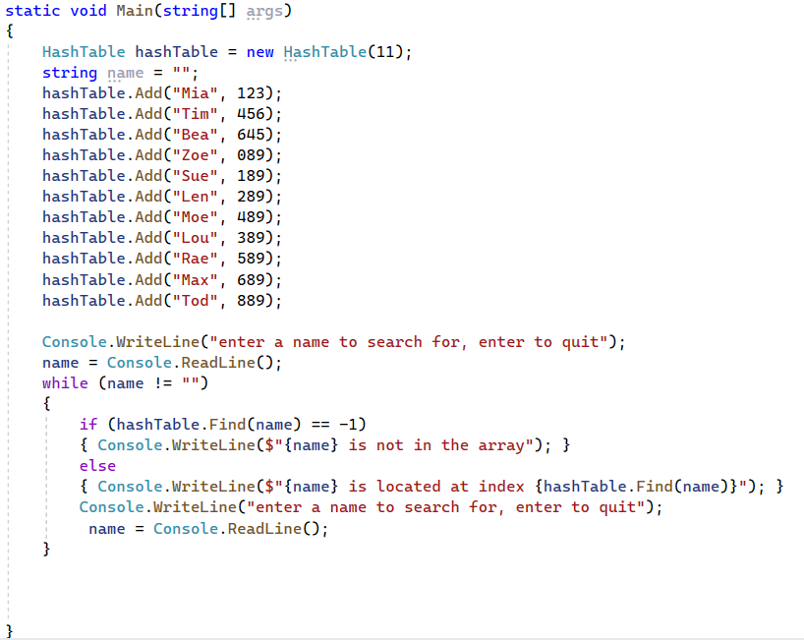

We need 3 methods in the hashtable class. You can see the headers for these in the class definition.

Here is the code for the Add method.

Write the final two methods, Hash and Find.

The hash method should receive a key value (string) and return a numerical hash value between 0 and 10.

The find method should receive a key value (string) and return the location of that item or -1 if the item is not found.

Test and fully annotate all your code and submit to the assignment